Rose Essential Oil – The Luxurious Essence of Purity and Wellness
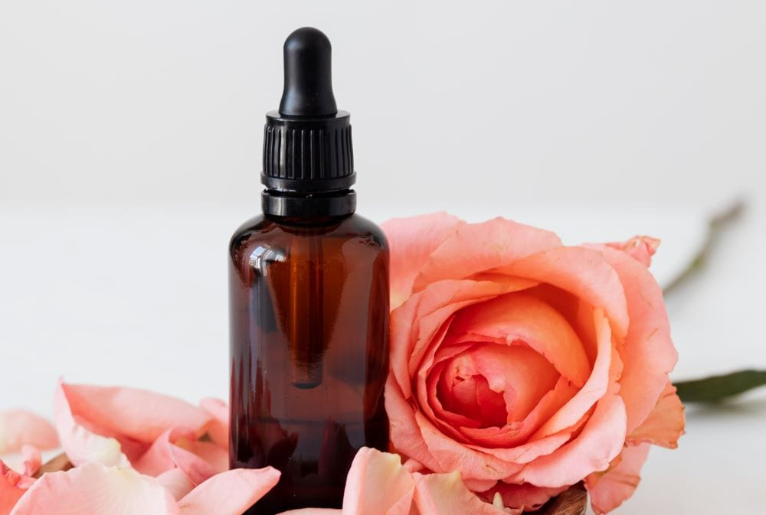

Introduction
Among the most exquisite and valuable essential oils in the world, Rose Essential Oil—often called Rose Otto or Rosa Damascena Oil—is a timeless symbol of beauty, luxury, and wellness. Extracted from delicate rose petals through a meticulous steam distillation process, this oil captures the true essence of nature’s most fragrant flower.
At The Export Express, we specialize in sourcing and exporting 100% pure, therapeutic-grade Rose Essential Oil from India — produced under strict quality standards for skincare, perfumery, aromatherapy, and pharmaceutical applications.

Botanical Overview
- Botanical Name: Rosa damascena (Damask Rose)
- Common Names: Rose Otto, Rose Essential Oil
- Extraction Method: Steam Distillation
- Plant Part Used: Fresh Rose Petals
- Origin: India
- Color & Appearance: Pale yellow to light amber liquid
- Aroma: Deep, rich, sweet-floral fragrance with soft spicy undertones

Technical Specifications
Parameter | Specification
Purity | 100% Pure & Natural
Specific Gravity | 0.950 – 0.980 @ 20°C
Refractive Index | 1.485 – 1.520 @ 20°C
Solubility | Soluble in alcohol and oils; insoluble in water
Shelf Life | Up to 24 months (when stored properly)
Packaging Options | 1 kg, 5 kg, 25 kg, 50 kg & 180 kg food-grade containers
Availability | In Stock

Extraction Process – The Craft Behind Every Drop
Our Rose Otto Essential Oil is carefully extracted through steam distillation of fresh Rosa damascena petals. Each kilogram of oil requires approximately 3,000–4,000 kg of handpicked rose flowers, making it one of the most precious essential oils in the world.
This traditional method ensures the preservation of vital aromatic compounds such as citronellol, geraniol, and nerol, giving the oil its characteristic aroma and therapeutic potency.

Key Benefits and Uses

1. Skincare & Beauty
- Deeply hydrates and rejuvenates dry or mature skin
- Helps reduce wrinkles, scars, and blemishes
- Promotes a healthy, glowing complexion
- Soothes redness and irritation — ideal for sensitive skin

2. Aromatherapy & Emotional Wellness
- Promotes relaxation and relieves stress
- Acts as a natural mood enhancer and aphrodisiac
- Encourages emotional balance, confidence, and inner calm
- Supports restful sleep and overall mental clarity

3. Hair & Scalp Health
- Strengthens hair follicles and reduces dryness
- Adds a natural floral fragrance to hair oils and shampoos
- Helps maintain scalp hydration and elasticity

4. Therapeutic & Medicinal Uses
- Traditionally used to ease respiratory discomfort and boost immunity
- Anti-inflammatory and antibacterial properties aid skin healing
- Balances hormones and supports women’s wellness during PMS or menopause
- Promotes emotional stability and relaxation in aromatherapy blends

Applications Across Industries
Sector | Application
Cosmetics & Skincare | Moisturizers, face serums, toners, lotions, and creams
Perfumery | Luxury perfumes, attars, and aromatic blends
Pharmaceutical | Used in natural formulations for stress relief and skincare
Aromatherapy | Essential oil diffusers and massage oils
Wellness & Spa | Relaxation therapies, massage blends, and bath oils
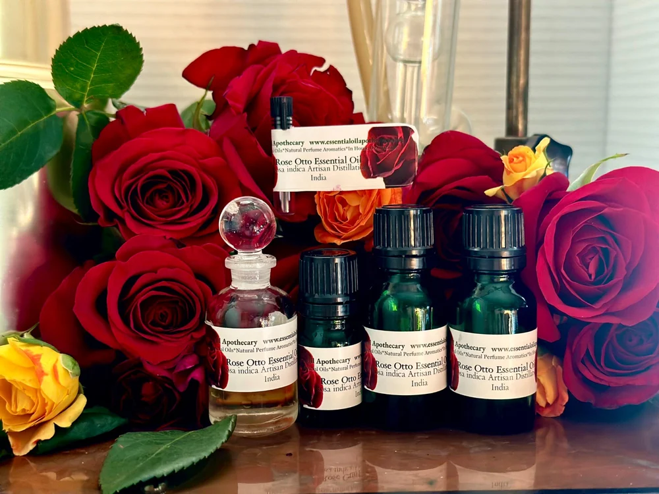

Why Choose Our Rose Essential Oil
- 100% Pure & Natural: No synthetic additives or fillers
- Therapeutic Grade: Steam-distilled for maximum potency
- Ethically Sourced: From sustainable farms and eco-friendly processes
- Export Quality: Tested for purity, aroma, and performance
- Custom Packaging & Bulk Supply: From 1 kg laboratory use to 180 kg industrial drums

Rose Otto vs. Other Rose Oils
Type | Extraction Method | Price Range | Primary Use
Rose Otto (Steam Distilled) | Steam Distillation | High | Perfumery, skincare, aromatherapy
Rose Absolute | Solvent Extraction | Moderate to High | High-end perfumery, cosmetics
Rose CO₂ Extract | Supercritical CO₂ | Premium | Therapeutic blends, luxury formulations
Rose Otto remains the most expensive and sought-after due to its purity, intricate extraction process, and the immense number of rose petals required to produce even a small quantity of oil.

Sustainability & Ethical Practices
We are committed to sustainable sourcing and environmentally responsible production. Our rose oil is obtained from farms that follow eco-friendly cultivation methods, minimizing waste and supporting fair trade practices.
Each batch is tested for purity, composition, and consistency, ensuring international export quality standards.

How to Use
- Aromatherapy: Add a few drops to diffusers for stress relief.
- Topical Application: Dilute with carrier oil (like jojoba or almond oil) for radiant skin.
- Massage Oil: Combine with sandalwood or jasmine oil for relaxation.
- Hair Care: Mix 2–3 drops into shampoo or conditioner.
- Bath Ritual: Add to warm bath water for a luxurious spa experience.

Safety Information
- For external use only; avoid ingestion.
- Always dilute before topical application.
- Conduct a patch test before use on sensitive skin.
- Not recommended during pregnancy or for young children.

Global Export & Custom Orders
At The Export Express, we export premium-grade Rose Otto Essential Oil along with a wide range of natural essential oils — including Sandalwood, Jasmine, Vetiver, Agarwood, and more.
Whether you’re a cosmetic manufacturer, aromatherapy brand, or wellness retailer, share your technical requirements and intended applications, and our team will deliver custom-matched, export-ready formulations that meet global standards.

Conclusion
Rose Essential Oil is not just an aromatic luxury—it’s a holistic experience that connects centuries of tradition, wellness, and elegance. From skincare to aromatherapy, every drop encapsulates the purity and grace of nature.
At The Export Express, we take pride in supplying the world’s most refined essential oils — crafted in India and cherished globally.

